###### 

***PUCIT***

Punjab University College of Information Technology

**First Deliverable**

**Version 1.0**

Table of Contents

*1 Introduction 3*

*1.1 Project/Product Feasibility Report 3*

1.1.1 Technical Feasibility 3

1.1.2 Operational Feasibility 4

1.1.3 Economic Feasibility 4

1.1.4 Schedule Feasibility 5

1.1.5 Specification Feasibility 5

1.1.6 Information Feasibility 5

1.1.7 Motivational Feasibility 6

1.1.8 Legal & Ethical Feasibility 6

*1.2 Project/Product Scope 6*

*1.3 Project/Product Costing 7*

1.3.1 Project Cost Estimation by Function Point Analysis 7

1.3.2 Project Cost Estimation by using COCOMO’81 (Constructive Cost Model): 11

*1.4 CPM - Critical Path Method 13*

CPM DIAGRAM 16

Critical Path Evaluation 17

The Critical path : 18

*1.6 Introduction to Team member and their skill set 19*

*1.7 Tools and Technology with reasoning 20*

*1.8 Vision Document 21*

*1.9 Risk List 22*

# 

# 1 Introduction

In today’s era of technology, where foreign countries are facilitating educational purposes through online platforms, Pakistan is lacking such platforms for universities. So, our basic purpose is to create a web application, that will allow schools to register them on that web application, and make their work easy rather than to work manually, with pages, hard files, and with a lot of other essential manual equipment and then storing them in their offices for a long time. Our application will help them to digitize the different operations of educational institutions in order to enhance the overall productivity and efficiency of institutions. First part of this deliverable is all about planning and scheduling of project. This deliverable must contain following artifacts:

1. Project Feasibility
2. Project Scope
3. Project Costing
4. Critical Path Method Analysis (CPM Analysis)
5. Gantt Chart
6. Introduction to team members
7. Tools and Technologies
8. Vision Document
9. Risk List

## 1.1 Project/Product Feasibility Report

When a project is started the first matter to establish is to assess the feasibility of a project or product. Feasibility means the extent to which appropriate data and information are readily available or can be obtained with available resources such as staff, expertise, time, and equipment. It is basically used as a measure of how practical or beneficial the development of a software system will be to you (or organization). This activity recurs throughout the life cycle.

There are many types of feasibility:

* Technical
* Operational
* Economic
* Schedule
* Specification
* Information
* Motivational
* Legal and Ethical

### 1.1.1 Technical Feasibility

**Practicality of the proposed technology:**

If we are asked whether the proposed technology is practical or not? The answer would be “YES” because we possess the required technology and techniques that are necessary to build the web app. It requires the following set of technologies:

As this is a web-application, we had many options to opt different OS and programming languages, but we chose Windows as OS as there’s no specific requirement of OS for running a web application from client side. It can also be run through any smartphone.

For front-end HTML, CSS & React are chosen, while for back-end Mongo-DB, Node.js, and Express.js will be used. Visual Studio Code (VS Code) is chosen as IDE for web development and web browser for running and checking the working of application.

**Possessing the needed technology:**

We do have access to the required tools and technologies.

**Technical expertise:**

Our team is learning on most of the mentioned technologies and the remaining technologies will be learnt by the particular team members according to the tasks assigned to them.

**Reasonable schedule:**

We will try our best to achieve the milestones in the same time and order as mentioned in the schedule.

### 1.1.2 Operational Feasibility

In this area the question arises as:

* Whether the problem is worth solving and if the solution provided for the problem works or not?
* How do end users and managers feel about the problem or solution?

So, basically in this project the Target audience is **All Educational Institutions**.

For us this problem is worth solving as there is no reliable online platform where several schools may register their institutions, and can use the application according to their needs, rather than they make a new one web application separately which is costlier and time taking way. Evaluation of technical ability of the staff to operate the project is the main aim of operational feasibility. The application is easy to use. Users will find it comfortable. Operations are smooth as we are more focused in providing the users easiness. They can place the complaint online on our portal. We will check the feasibility of Admin and the users’ communication compatibility. The basic operations will be run fluently with the automated jobs done by our portal.

### 1.1.3 Economic Feasibility

**● Cost Estimates:**

**Development Cost**: In development cost, we consider the cost of Tools,

Hardware and technologies that we are using. Moreover, it also includes the cost

of estimated effort of your team members.

**Operational Cost**: In operational cost, we consider the defects per KLOC and the removal cost of these defects. It wouldn’t be much high as there are many algorithms that could provide help in development. Once the algorithm is developed, the operational cost wouldn’t be much high.

**Maintenance Cost:** The cost of system maintenance represents a large proportion of the budget of most organizations that use software systems. More than 65% of software life-cycle cost is spent in the maintenance activities.

**● Benefit Estimates**

* **Tangible** 
  + Developing a new product to save time and money.
* **Intangible** 
  + Increase the number of clients that deal with Application.
  + Customers will no longer spend hours waiting for availability of staff.
  + Increase client’s happiness.
  + Increase user satisfaction

### 1.1.4 Schedule Feasibility

Project will be completed in the time period of six months and is divided into several deliverables which are to be submitted. Each deliverable will contain progress of the project. Development will be started in the last 3 months. For discussion sessions, several meetings are scheduled as well. This way will allow us to work in an efficient way. Individual work will be examined on a regular basis.

### 1.1.5 Specification Feasibility

As all the requirements and specifications are mentioned and are crystal clear, so it is a well-defined project. Moreover, the scope of the project is defined, and limitations are mentioned, so it is quiet specific what to build.

Developing an algorithm for suggesting people most suitable option for them is most risky requirement but we can handle it on expense of some filtering techniques.

Our software will have the following specifications:

* Operating System like Windows, Linux, Mac OS, Android etc.
* Minimum 2 GB RAM or more.
* Processor: Pentium 4 or more
* Internet
* PC Hard disk: 120 GB
* Any browser with JS support.
* Empty Storage 200 MB for mobile app.

### 1.1.6 Information Feasibility

We have enough information to complete this project. All the team members have done complete requirement gathering to get the required information to build this software. Moreover, official documents of the university will help in developing a dynamic form portal i.e. one main objective of the application. Our research has helped us a lot in gathering the necessary information to build the project.

### 1.1.7 Motivational Feasibility

* **Desirability:**
  + The value of achieving the goal
* **Feasibility:**
  + The likelihood that you can achieve the goal
* **Progress:**
  + Your accomplishments as you work to reach your goal
* **Reward:**
  + The payoff when you reach the goal

### 1.1.8 Legal & Ethical Feasibility

In our country, according to the **Islamic Law** as well as the **1973 constitution**, there’s no such restriction for using that web application.

Security measures will be taken to protect the information provided by students during Signing in the application. Data processing systems must comply with the local data protection Acts. It must determine that any infringement and everything must comply with the legal requirements. Application will not reveal secrets of the university to prevent exercise of insider trading, etc. and to preserve the goodwill of the University.

The Legal notices and documentation will be done at Market End where we implement our product, proper contract will be signed to minimize issues.

## 1.2 Project/Product Scope

The purpose of building “School Management System” is to manage the student’s complaints online rather than manually. This is a data driven project i.e. it includes both mobile application and web app for the system that work independently. This application will facilitate the users especially students to submit applications to the university management online. The user will also be notified about the response from the management. This application will provide a chat bot that will assist the user with FAQs. Moreover, admin will be able to create dynamic forms as per user requirements. The whole project will grow in an incremental manner.

**Objectives:**

* View records.
* Maintain records online.
* Admin can add, delete, update and view student information.
* To avoid delays in the normal office process
* Students who hesitate to go to office personally will be benefited

**Benefits:**

* To get rid from manual system.
* Students will not have to wait in long queues for any small application
* Ease for both the students and admin staff
* Students do not have to come to the office again and again for any small matter

## 1.3 Project/Product Costing

A metric is some measurement we can make of a product or process in the overall development process. Metrics are split into two broad categories:

* Knowledge oriented metrics: these are oriented to tracking the process to evaluate, predict or monitor some part of the process.
* Achievement oriented metrics: these are often oriented to measuring some product aspect, often related to some overall measure of quality of the product.

Most of the work in the cost estimation field has focused on algorithmic cost modeling. In this process costs are analyzed using mathematical formulas linking costs or inputs with metrics to produce an estimated output. The formulae used in a formal model arise from the analysis of historical data. The accuracy of the model can be improved by calibrating the model to your specific development environment, which basically involves adjusting the weightings of the metrics.

**Cost estimation can be done by just one methodology.**

### 1.3.1 Project Cost Estimation by Function Point Analysis

Function-oriented software metrics use a measure of the functionality delivered by the application as a normalization value. Since ‘functionality’ cannot be measured directly, it must be derived indirectly using other direct measures. Function-oriented metrics were first proposed by Albrecht, who suggested a measure called the function point. Function points are derived using an empirical relationship based on countable (direct) measures of software’s information domain and assessments of software complexity.

Function Point Analysis can provide a mechanism to track and monitor scope creep. Function Point counts at the end of requirements; analysis, design, code, testing and implementation can be compared. The function point count at the end of requirements and/or designs can be compared to function points actually delivered. If the project has grown, there has been scope creep. The amount of growth is an indication of how well requirements were gathered by and/or communicated to the project team. If the amount of growth of projects declines over time it is a natural assumption that communication with the user has improved.

Function points are computed by completing the table shown in the figure below. Five information domain characteristics are determined and counts are provided in the appropriate table location.

Information domain values are defined in the following manner:

**Number of user inputs:** Each user input that provides distinct application-oriented data to the software is counted. Inputs should be distinguished from inquiries, which are counted separately.

**Client:**

* Log in (Medium)
* Forgot Password (Low)
* Update Client (Low)
* Select Form (Medium)
* FAQ Chabot (Low)
* Customize Form (High)
* Form filling (High)
* Request Approval (Medium)
* Log out (High)

**Admin:**

* Create Forms (High)
* Create Accounts (High)
* Delete Accounts (Medium)
* Log in (High)
* Log out (High)
* Respond to requests (Medium)

**Number of user outputs:** Each user output that provides application-oriented information to the user is counted. In this context output refers to reports, screens, error messages, etc. Individual data items within a report are not counted separately.

* Output screens and reports (High)
* Notifications (Low)
* Answers to FAQ (Low)
* Forms (Medium)
* Account settings (Low)
* Search bar Response (Medium)

**Number of user inquiries:** An inquiry is defined as an on-line input that results in the generation of some immediate software response in the form of an on-line output. Each distinct inquiry is counted.

* Prompt and interrupts (Medium)
* Search Bar (Low)
* Feedback (High)

**Number of files:** Each logical master file (i.e., a logical grouping of data that may be one part of a large database or a separate file) is counted.

* Databases and directories (High)
* System data file (Medium)

**Number of external interfaces:** All the machine-readable interfaces (e.g., data files on storage media) that are used to transmit information to another system are counted.

* Printers Generate fee challan (Low)
* Databases (High)

Once these data have been collected, a complexity value is associated with each count. Organizations that use function point methods develop criteria for determining whether a particular entry is simple, average, or complex. Nonetheless, the determination of complexity is somewhat subjective.

|  |  |  |  |  |  |  |  |  |
| --- | --- | --- | --- | --- | --- | --- | --- | --- |
| **Measurement**  **Parameter** | **Count** | **Weighting Factor**   |  |  |  | | --- | --- | --- | | **Low** | **Average** | **High** | | | | **Total** |
| **Number of user inputs** | 15 | 3 * 3 = 9 | 5 * 4 = 20 | 7 * 6 = 42 | 71 |
| **Number of users**  **outputs** | 6 | 3 * 4 = 12 | 2 * 5 = 10 | 1 * 7 = 7 | 29 |
| **Number of users inquires** | 3 | 1 * 3 = 3 | 1 * 4 = 4 | 1 * 6 = 6 | 13 |
| **Number of files** | 2 | 0 * 7 = 0 | 1 * 10 = 10 | 1 * 15 = 15 | 25 |
| **Number of external**  **interfaces** | 3 | 1* 5 = 5 | 0 * 7 = 0 | 1 * 10 = 10 | 15 |
|  |  |  | | **Count Total** | **153** |

**Value adjustment factor (Fi) Rating**

1. Data communications 4

2. Distributed data processing 2

3. Performance 4

4. Heavily used configuration 3

5. Transaction rate 1

6. On-Line data entry 4

7. End-user efficiency 4

8. On-Line update 3

9. Complex processing 3

10. Reusability 2

11. Installation ease 4

12. Operational ease 4

13. Multiple sites 0

14. Facilitate change 2

Sum of Value adjustment factor (Fi) = 40

**FP est.=Count Total*[0.65 + 0.01 *(Fi)]**

**FP est. = 153* [0.65 + 0.01 * (40)] FP est. = 160.65 = 161 approx.**

Where count total is the sum of all FP entries (153) obtained from above figure and (Fi) 40 is value adjustment factor (VAF) is based on 14 general system characteristics (GSC's) that rate the general functionality of the application being counted. Each characteristic has associated descriptions that help determine the degrees of influence of the characteristics. The degrees of influence range on a scale of zero to five, from no influence to strong influence.

Finally, Total Project Cost and Total Project Effort are calculated given the average productivity parameter for the system.

**\*Assuming: 1 month = 22 working days, per person**

**Average productivity** = 5 FP/month (per day: 0.23 FP)​

**Cost/FP = labor rate / productivity parameter**

Cost/FP= 20000/23

**Cost/FP= 870 RS/FP**

**Total Project Cost = FP estimation * (Cost/FP)**

Total Project Cost = 161* 870

Total Project Cost = **140, 070**​ ​ **RS**​

**Total estimation effort = FP estimation / productivity parameter**

Total estimation effort = 161/23

Total estimation effort = 7pm. (7 * 22 = **154**​  **days**)​

### 1.3.2 Project Cost Estimation by using COCOMO’81 (Constructive Cost Model):

Boehm's COCOMO model is one of the mostly used models commercially. The first version of the model delivered in 1981 and COCOMO II is available now. COCOMO 81 is a model that allows one to estimate the cost, effort, and schedule when planning a new software development activity, according to software development practices that were commonly used in the 1970s through the 1980s.

It exists in three forms, each one offering greater detail and accuracy the further along one is in the project planning and design process. Listed by increasing fidelity, these forms are called Basic, Intermediate, and Detailed COCOMO. However, only the Intermediate form has been implemented by USC in a calibrated software tool.

Three levels:

1. **Basic:** Is used mostly for rough, early estimates.
2. **Intermediate:** Is the most commonly used version, includes 15 different factors to account for the influence of various project attributes such as personnel capability, use of modern tools, hardware constraints, and so forth.
3. **Detailed:** Accounts for the influence of the different factors on individual project phases: design, coding/testing, and integration/testing. Detailed COCOMO is not used very often.

Each level includes three software development types:

1. **Organic:** Relatively small software teams develop familiar types of software in an in-house environment. Most of the personnel have experience working with related systems.
2. **Embedded:** The project may require new technology, unfamiliar algorithms, or an innovative new method
3. **Semi-detached:** Is an intermediate stage between organic and embedded types.

**Basic COCOMO Type Effort Schedule**

**Organic PM= 2.4 (4)1.05 = 10.08 TD= 2.5(3)0.38 = 2.85**

**Semi-Detached PM= 3.0 (3)1.12 = 10.08 TD= 2.5(2)0.35 = 1.75**

**Embedded PM= 2.4 (3)1.20 = 8.64 TD= 2.5(2)0.32 = 1.6**

**PM= person-month (effort)**

Total PM = 10.08 + 10.086 + 8.64 = 28.8

**KLOC= lines of code, in thousands**

Total Line of code (in thousand) = 6 + 3 + 4 = 13

**TD= number of months estimated for software development (duration)** Total TD = 2.85 + 1.75 + 1.6 = 6.2

The schedule is determined using the Basic COCOMO schedule equations.

**People Required = Effort / Duration**

= 28.8 / 6.2

= **4-5 approximately**

## 1.4 CPM - Critical Path Method

In 1957, DuPont developed a project management method designed to address the challenge of shutting down chemical plants for maintenance and then restarting the plants once the maintenance had been completed. Given the complexity of the process, they developed the Critical Path Method (CPM) for managing such projects.

CPM provides the following benefits:

* Provides a graphical view of the project.
* Predicts the time required to complete the project.
* Shows which activities are critical to maintaining the schedule and which are not.

CPM models the activities and events of a project as a network. Activities are depicted as nodes on the network and events that signify the beginning or ending of activities are depicted as arcs or lines between the nodes. The following is an example of a CPM network diagram:

Steps in CPM Project Planning:

* 1. Specify the individual activities.
  2. Determine the sequence of those activities.
  3. Draw a network diagram.
  4. Estimate the completion time for each activity.
  5. Identify the critical path (longest path through the network)
  6. Update the CPM diagram as the project progresses.

|  |  |
| --- | --- |
| **Activity Name** | **Symbol** |
| **Requirement Gathering** | A |
| **Proposal** | B |
| **Cost Estimation** | C |
| **Cost Analysis** | D |
| **Critical Path** | E |
| **Gantt Chart** | F |
| **DFD all Levels** | G |
| **Use case Diagram** | H |
| **Sequence Diagram** | I |
| **ER Diagram** | J |
| **Database Model** | K |
| **Creating Database** | L |
| **Development** | M |
| **Testing** | N |
| **Deployment** | O |
| **Maintenance** | P |

|  |  |  |  |
| --- | --- | --- | --- |
| **Activity Name** | **Symbol** | **Duration(**​ **days)** | **Predecessor** |
| **Requirement Gathering** | **A** | **3** | **-** |
| **Proposal** | **B** | **2** | **A** |
| **Cost Estimation** | **C** | **2** | **B** |
| **Cost Analysis** | **D** | **2** | **C** |
| **Critical Path** | **E** | **1** | **D** |
| **Gantt Chart** | **F** | **2** | **E** |
| **Use Case Diagram** | **G** | **2** | **A, F** |
| **DFD all Levels** | **H** | **2** | **A,G** |
| **System Specification** | **I** | **3** | **H** |
| **ER Diagram** | **J** | **7** | **I** |
| **Sequence Diagram** | **K** | **2** | **J** |
| **Prototyping** | **L** | **10** | **K, H** |
| **Database Model** | **M** | **4** | **J** |
| **Creating Database** | **N** | **3** | **J, M** |
| **Development** | **O** | **60** | **N, L, I** |
| **Testing** | **P** | **8** | **O** |
| **Deployment** | **Q** | **3** | **P** |
| **Maintenance** | **R** | **15** | **Q** |

**6. Update CPM Diagram**

As the project progresses, the actual task completion times will be known and the network diagram can be updated to include this information. A new critical path may emerge, and structural changes may be made in the network if project requirements change.

### CPM DIAGRAM

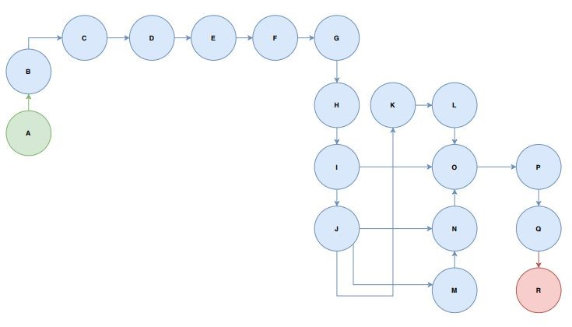

Network Diagram for the above-mentioned activities

### *Critical Path Evaluation*

The parameters and slacks are calculated as follows:

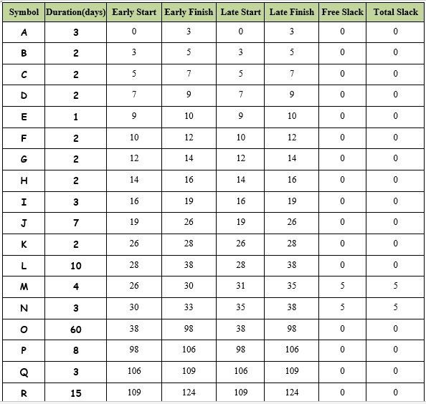

### The Critical path :

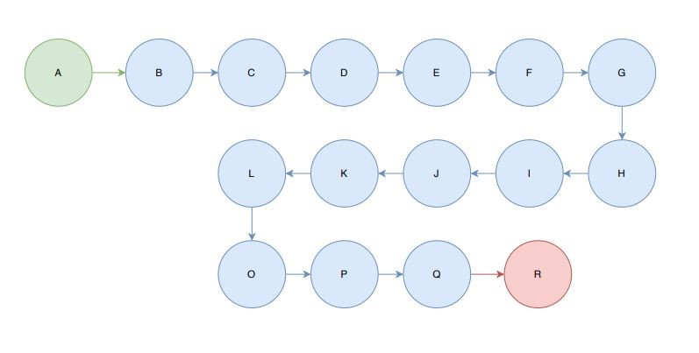

## 1.6 Introduction to Team member and their skill set

Our team is consisting of 4 members and a supervisor. Brief introduction to every team member is given bellow.

|  |
| --- |
| **Supervisor:** Umair Babar |
| **Group Leader:** Moeez Hayder |
| **Group Members:**   |  |  |  | | --- | --- | --- | | **Name** | **Roll Number** | **Skills** | | Moeez Hayder | BSEF19A537 | * Project Management * Resource Management * Coding * Back-end Development (Node.js, Express.js, JS) * MERN Stack Development | | Atif Aqeel | BSEF19A518 | * Coding * Research * Documentation * Database Management * Front-end Development (HTML, CSS, JS, Boot Strap) * Testing | | Muhammad Ahsan | BSEF19M508 | * Coding * Research * Documentation * Logic Building * Front-end Development (React.js, HTML, CSS, JS, Boot Strap) | | Shahwar Munir | BSEF19M507 | * Coding * Research * Documentation * Testing * Front-end Development (React.js, HTML, CSS, JS, Boot Strap) | |
|  |

## 1.7 Tools and Technology with reasoning

* **Development Platform:** MERN Stack
* **Target Platform:** All Modern Browsers
* **Programming Language:** JavaScript

**Working Tools:**

|  |  |  |
| --- | --- | --- |
| **Tool** | **Usage** | **Work level** |
| **VS Code** | **IDE** | **Full MERN Stack Development** |
| **Node.js and Express.js** | **Framework** | **Supports JavaScript as backend** |
| **REACT JS** | **Front-End Interface** | **Single page front-end application** |
| **Photoshop** | **Picture Edit** | **Front End Designing** |
| **JavaScript** | **Base Language** | **Backend Code** |
| **Microsoft Excel** | **WBS** | **Gantt Chart Maker** |
| **Microsoft Word** | **Text Editor** | **Documentation** |
| **Creatly,**  **Draw.io** | **Diagrams** | **Planning Diagrams** |
| **Mongo DB Compass** | **DB Editor** | **Show/Edit/Create/Update Database** |
| **HTML, CSS, JS, Boot Strap** | **Front End** | **Front End Outputs** |
| **MongoDB** | **DB storages** | **Database** |

Note: All the required Software and Libraries are free of cost.

## 1.8 Vision Document

A Vision Document is the starting point for most software projects. It is the primary deliverable and is therefore the first document produced in the planning process. The main purpose of this document is to move the project forward into detailed project

planning and ultimately into development.

The Vision Document is designed to make sure that key decision makers on both sides have a clear, shared vision of the objectives and scope of the project. It identifies

alternatives and risks associated with the project. Finally, it presents a budget for the

detailed planning phase for the stakeholders to approve.

**Project Details**

We want to create a SMS project on which multiple admins of several educational institutes can register their institute and create the accounts of their teacher and students, where they have access to their assigned courses, gradebooks, and attendance sheets, announcements by teacher or admin. This SMS will not only be accessible within the institute but also from anywhere using the internet.

**Purpose**

The goal for this project is to provide web application to the educational institutes to use the facility of SMS online by just creating an admin account on our website.

**Problem Statement**

In today’s era of technology, where US and UK countries are facilitating educational purposes through online platforms, Pakistan is lacking such platforms in educational institutions.To bring our people at a certain level of ease, we have come up with an idea that could help people (admins, teachers, students, etc.) of educational institutions to use a web application at any time or at any place around the country in no time rather than to visit the software houses first to request for building a specific application to meet their purposes. Our application will help them to digitize the different operations of educational institutions in order to enhance the overall productivity and efficiency of institutions rather than to work manually, with pages, hard files, and with a lot of other essential manual equipment (stationary goods) and then storing them in their offices for a long time.

**Users**

The key users of this web-app will be the individuals (admins, teachers, students, etc.) of educational institutes specially of our country that are connected to the world through internet and find it hard to work manually.

**Alternatives**

Currently there are very few alternatives or competitors and that are not belonging to Pakistan.

**Stakeholders**

* End Users.
* Schools desiring Online SMS.
* Investors.
* Service Providers.
* Server Service Providers.

**Constraints:** The main constraint of the product is to meet what expectations are made from this product and really facilitating the students, teachers and other individuals attached with a particular institute.

**Limitations:** Time & resources constraints are main limitations.

**System Requirements:** The system Requirements are well defined in this document.

## 1.9 Risk List

Following are some risks that have been identified in our project. This list will be updated later in the project as we face any other possible risks. The risks are given for SMS as follows:

**1. Time Management:**

Scope and functionality of the project must comply with the schedules otherwise project completion may be delayed. Mitigation or contingency actions: All the team members of the project must strictly follow the schedules. We are asked for the implementation of new requirements, there might be some extra time required for learning some particular technique by a certain team member.

**2. Technology Advancement:**

Technology is changing day by day. Advancement in technology may not accept the terms used in our project. Mitigation or contingency actions: Develop the project considering maintainability aspects. There might be some extra time required for learning some particular technology by a certain team member

**3. Business Aspects:**

If the target audience is not aware of such a website, the website will be of no use. Mitigation or contingency actions: Marketing of the project done properly building interest of restaurants. The performance also depends on the level of user interaction and level of “Ease of Use”.

**4. Team Members:**

Issues Whole work is divided into team members according to their skills. In case of any member’s absence in the meeting, there may be a difficulty in completing the project in time.

Mitigation or contingency actions: Team members are very strictly made to attend every meeting.

-------------------------------------------------------------------------------------------------------

END!